Pokhara University

Level: Bachelor | Semester – Spring | Year : 2006
Programme: BE |  | Full Marks: 100
Course: Basic Electrical Engineering |  | Time : 3hrs.

Candidates are required to give their answers in their own words as far as practicable.
The figures in the margin indicate full marks.

Attempt all the questions.

 | - Use the concept of Mesh analysis to find mesh current in the given figure.  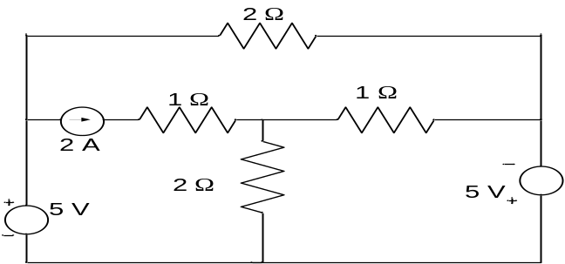  - Use Norton's theorem to calculate the current in 6 Ω resistor in the given network.  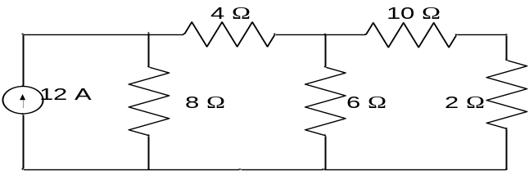 | 7  8
 | - State maximum power transfer theorem. Use superposition theorem to find the current through 20 Ohm resistance in the following circuit.  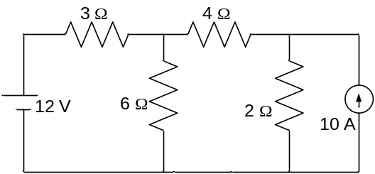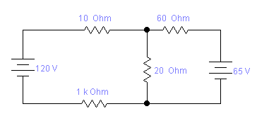  30 Ohm  - Use Thevenin's theorem to calculate the current flowing through 4 Ω resistor. | 7  8
 | - 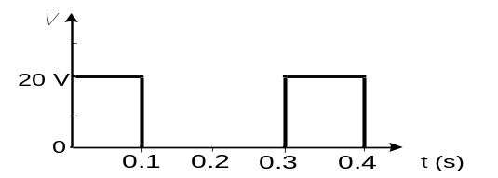Compute the average and effective values of the square voltage wave shown in figure below.  - An ac series circuit has a resistance of 10 Ohm and an inductance of 0.2 H and capacitance of 60 μf. If the applied voltage is 200 V, calculate resonant frequency and power at resonance. | 7  8
 | - How will a series RLC circuit be in resonance? Also describe the process for the measurement of power in a three phase circuit by two wattmeters method.  - For the star connected three phase circuit calculate the line current and total power consumed by the load if Z = 40 + j50 and the line voltage v = 400 V. | 8  7
 | - Draw and explain the equivalent circuit of a single phase transformer. Also, draw the phasor diagram of the transformer at 0.6 pf lagging.  - A 220/440 V, 50 Hz transformer gave the following data on tests. Obtain the parameters of the equivalent circuit.  Open circuit test: 220 V 0.6 A 66 W  (Measured on LV side)  Short circuit test: 17 V 10 A 80 W  (Measured on HV side) | 4+3  8
 | - What do you mean by armature reaction in dc generator? How the effect of armature reaction can be minimized?  - A 220 V dc shunt motor takes 4 A at no load and runs at speed of 1000 rpm. When the motor is loaded the speed drops to 960 rpm. Calculate the current drawn by the motor from the supply when loaded. Given that R_{a} = 0.5 Ω and R_{f} = 110 Ω. Consider the flux to be constant. | 7  8
 | Write short notes on (Any Two):  - Hysteresis loss and eddy current loss  - Sinusoidal signal voltage  - Basic requirements of an electrical measuring instrument | 5×2

